Comparison between different Data Visualization Software

Inhalt

Introduction 3

Why Data Visualization Software? 3

How can we Achieve this and what are the main needed features? 3

Less Coding Tools 4

Tableau 4

Pros: 4

Cons: 4

Infogram 5

Pros: 5

Cons: 5

Chartblock 6

Datawrapper 6

Plotly / Dash 6

Pros: 6

Cons: 6

Qlik 7

Pros: 7

Cons: 7

Kibana 8

Pros: 8

Cons: 8

Power BI 9

Pros: 9

Cons: 9

Coding required tools 10

Summary 11

3rd Place: Qlik 11

2nd Place: PowerBI 11

1st Place: Kibana + Elasticsearch 11

Explanations 12

Interactive Diagrams 12

Elasticsearch 12

Sources 13

# Introduction

## How can we Achieve this and what are the main needed features?

We can achieve this by choosing one of the following Visualization tools and implement it to our customer interfaces.

The main needed features are:

* A REST API that we are flexible which database we use to send data to the visualization software.
* Usable for both Presentations/Reports and data studying
* An Analytic Platform to make data studying easier, faster and more profitable
* Interactive Diagrams
* Opensource or free to use
* Able to deploy on a server

Non-Functional features would be:

* Pleasing diagrams
* Easy to setup
* No coding required

## Why Data Visualization Software?

Each day, a lot of companies collect huge amounts of data and knowledge about their customers, employees, the market and many other things but this knowledge is hidden in meaningless numbers. This data could be analysed and visualized to make user-friendly Diagrams that can help predicting market change or increase the profit by intelligent cost reduction.

This could either be used by an operator who uses fancy diagrams for his presentations and reports or for data analysts who study these diagrams and derive useful information to answer questions like “Why is the market in Great Britain rising although there is the Brexit and how can we take what is working in this region and bring it to other regions?”

# Less Coding Tools

## Tableau

Tableau is a paid data visualization tool optimized for big data in companies. Although it has an overwhelming amount of possibilities and this needs some time to learn, it is very easy to use especially for non-technicians. It is used only by drag n drop data fields to diagrams. It is also helping to choose which graph would be the best for every source of data.

### Pros:

* Desktop app where you can easily drag and drop different data to make graphs
* Easy share Data Visualizations in the Cloud
* Access shared Data on all devices
* No Code required

### Cons:

* Pricing
* Overwhelming amount of possibilities

#### Tableau Pricing

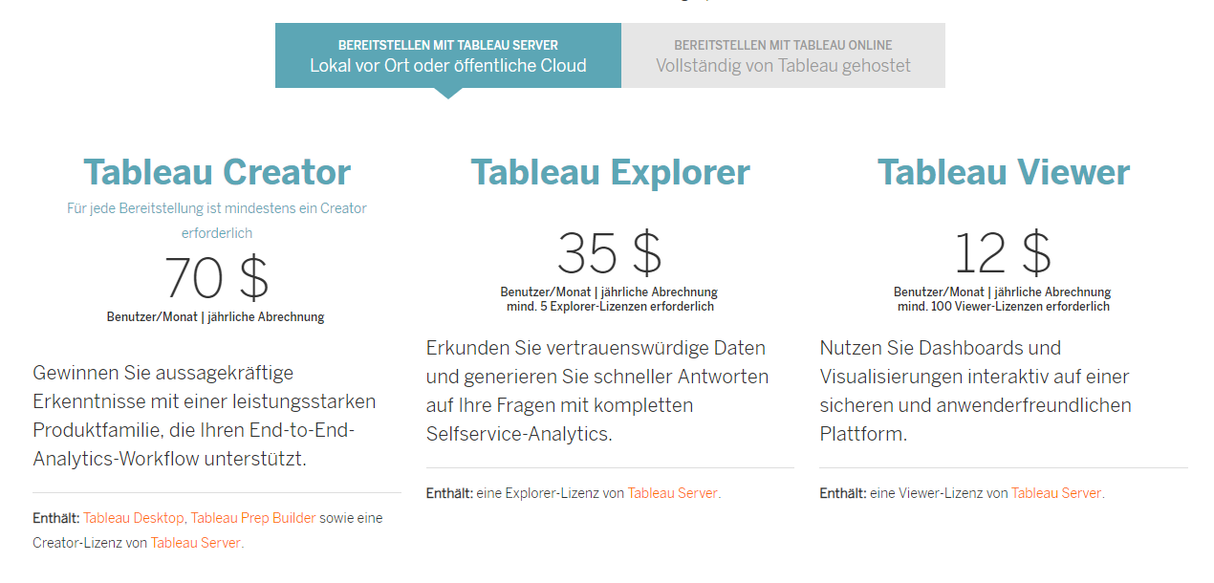

[Pricing Details](https://www.tableau.com/de-de/pricing/teams-orgs#server)

## Infogram

[Infogram](https://infogram.com/) is an online tool for creating graphs and diagrams.

It offers 5 different Databases (MySQL, Postgre, Amazon Redshift, Oracle and MS SQL Server) but no Rest connection because it is mainly used to make pretty graphs for presentations and reports.

Besides that, you can import data by upload files, with google drive, drop box and json

### Pros:

* Very nice for Presentations and Reports.
* Easy to use and intuitive
* Create Teams to work together on one document
* Really pretty style and design

### Cons:

* Pricey
* No Integrations for Websites
* No deep Analytic functions
* Not a great amount of functions and graphs

#### Infogram Pricing

[To Page](https://infogram.com/pricing)

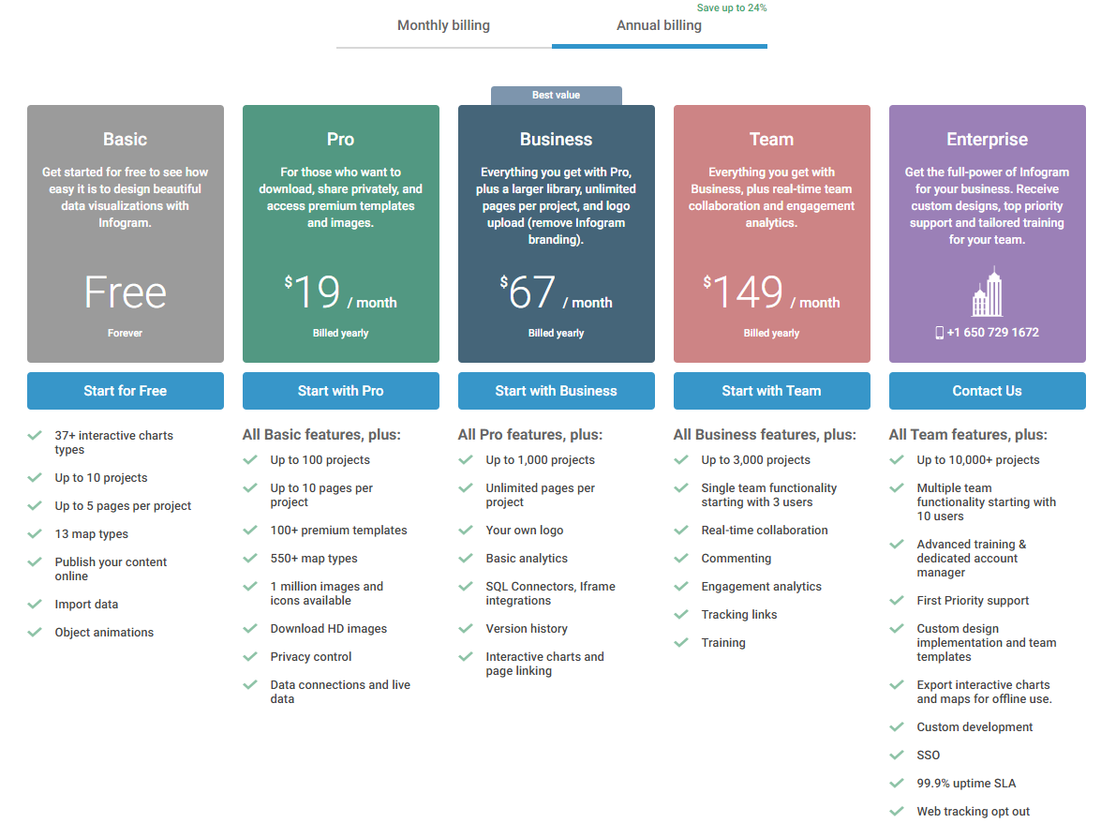

## Chartblock

[Chartblock](https://www.chartblocks.com/en/) is a very simple tool for only creating charts in a wizard form. At this time, it has no way to import data other than with csv, excel or typing so it is not relevant for our use case right now

## Datawrapper

[Datawrapper](https://www.datawrapper.de/) is a Graphic tool for mainly Journalists and has also no import functions besides csv and excel so it is also not relevant not relevant

## Plotly / Dash

[Dash](https://plot.ly/) is an open source Library for R and Python. No JavaScript is required but Python is. With Python you write both the html layout:

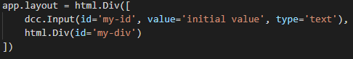

And the Logic:

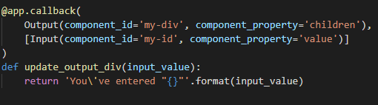

At the end you can easily run it as a local server:



### Pros:

* Opensource, but fees apply when in need of Support.
* Can be applied for Websites
* REST API could be coded
* Analytics also need to be extra coded
* The Interactivity comes out-of-the-box from the Dash Libraries

### Cons:

* Coding is required to create Visualizations so it is not usable for non-technician who cannot program Python

## Qlik

[Qlik](https://www.qlik.com/us) is a desktop tool focused on Data Analytics and is also capable of drawing Diagrams

### Pros:

* Code free Data Analytics from R and Python and with an AI
* For All Platforms including mobile
* Good for Data Studying and Presentations
* REST/JSON Api´s
* High Scalability with Multi-nodes
* In-memory data indexing
* Interactive Diagrams

### Cons:

* Pricing is different for every enterprise = no insight
* There are Tools that create more pleasant Diagrams.

## Kibana

[Kibana](https://www.elastic.co/de/products/kibana) is a graphic tool based on Elasticsearch, so we get the database (With REST API), very fast search and analytic features on top. Kibana is not only for visualization, but also to monitor queries on our data.

### Pros:

* Big Role-Permission System
* Easy to deploy on a Server
* Fancy Diagrams
* Very fast due to the Elasticsearch engine
* Intuitive to use
* Fast REST API available
* Interactive Diagrams
* Clustering and High availability
* Opensource and free

### Cons:

* Advanced Security features, cross-cluster replication, machine learning and 24/7/365 support only if paid (SaaS and on-Premise)

## Power BI

[PowerBI](https://powerbi.microsoft.com/de-de/) is the Business Intelligence tool from Microsoft. It is easy to use and has very pretty diagrams out-of-the-box. Sadly, I couldn’t try the REST API because you need to register this online and need Admin permissions.

### Pros:

* Interactive Diagrams
* Very easy and Intuitive to use without any Technical experience
* Fancy Diagrams
* You can make queries just by typing normal text (In English only)
* Custom Analytics written in Python or R

### Cons:

* [Pricey](https://powerbi.microsoft.com/de-de/pricing/)
* Not Opensource

# Coding required tools

Coding required tools are not usable for our case because we don’t want to write a new Program for Data Analytics and Visualization because there are enough out there, and it would be very expensive.

# Summary

There are a lot more tools out there, but I think I got the most important listed here. Although some of them are niche products they could also be interesting for some cases but will not get into the following top 3.

## 3rd Place: Qlik

Qlik is not bad but in comparison to Kibana and PowerBI setting up relations and creating diagrams is a bit more complex. When getting data from a REST connection it creates some more columns as in the original dataset which is very irritating. Another major point is that Qlik users are complaining about the high amount of RAM that is used.

## 2nd Place: PowerBI

Deciding between PowerBI and Kibana was a hard choice because PowerBI is really nice and easy to use. On top of that it has some features like the “normal language queries” and “on-click analysis” that makes them very good. Sadly, I couldn’t check the REST API due to a complex azure registration mechanism. A decisive factor was the deployment of PowerBI, there is only an extra tool called “PowerBI Report Server” which is only usable to spread reports inside a company that were previously done in PowerBI Desktop.

## 1st Place: Kibana + Elasticsearch

Kibana is even in most points with PowerBI but there are two major Points that make Kibana a little bit better:

1. Kibana and Elasticsearch are out-of-the-box designed to run on servers what makes them easier to deploy and access from many different devices without installing a desktop app.
2. Especially Elasticsearch is (as advertised) very fast because its built for that use case.

# Explanations

## Interactive Diagrams

An Interactive Diagram is a diagram where you can click on some information in the diagram and the rest of the data changes to this chosen piece of input.

Example: You have a Pie Chart with the percentages of male and female workers in the company. You also have a table with all the names of these workers. If you click on the female part of the pie chart, the name table will only show the names of female workers.

## Elasticsearch

[Elasticsearch](https://www.elastic.co/products/elasticsearch) is a clustered REST Search engine who saves data on a central place. It Is able to search in many ways like metric, geo, structured or unstructured. It is also able to aggregate this data so you can make predictions about market trends and patterns in this data.

Speed is very crucial in queries from a database so Elasticsearch has many complex algorithms to allow full-text querying, analytics as well as storing numeric and geo data.

Scalability gets more and more important to big companies because reliability can protect a lot from profit reduction or penalties. With Elasticsearch we can scale as much as we want and multi node clusters make this possible.

## Data Analytics

Big Data Analytics or short analytics is the term for examining lots of different data and is used for finding interesting correlations, making predictions. This could be used to get some advantages over competitors like more income or more effective marketing. The main target of this method is not to only use it for marketing decisions but to help the company to make better decisions.

Related terms: BI (Business Intelligence), aCRM (analytic CRM), OLAP (Online Analytic Processing)

## REST

REST (Representational State Transfer) is a http protocol that allows to get and send data through the internet. It is used for distributed systems to get data on-demand. It is a **stateless** connection type so no data about the client is saved between requests which gives more reliability and faster response times. REST is pretty simple to understand. The most important keywords are GET, PUT, POST, DELETE

* Get-Request: Sends a Request to the server what data is needed
* Put-Request: Sends data to Update this data on the server
* Post-Request: Sends new data to the collection of the server
* Delete-Request: Sends a request to delete existing data on the server

Client requests the Server like: https://myAdress.co/api/persons

The server captures the request and sends back (As JSON or XML format) for this example all persons in the collection.

# Sources

* [The best 20 big data visualization tools](https://bigdata-madesimple.com/review-of-20-best-big-data-visualization-tools/)
* <https://www.tableau.com/>
* <https://infogram.com/>
* <https://www.chartblocks.com/en/>
* <https://www.datawrapper.de/>
* <https://plot.ly/>
* <https://d3js.org/>
* <https://www.qlik.com/us>
* <https://www.qlik.com/us/pricing>
* <https://www.elastic.co/de/products/kibana>
* <https://www.elastic.co/products/elasticsearch/service/pricing>
* <https://www.elastic.co/products/elasticsearch>
* <https://powerbi.microsoft.com/de-de/>
* <https://powerbi.microsoft.com/de-de/pricing/>